A Brief Description of UART 2
1. Title 2
2. Objective 2
3. Theory (Multi-Level) 2
3.1 Beginner — Simple Intuition 2
3.2 Intermediate — Engineering View 2
3.3 Advanced — Signal/Architecture Level 3
TX Module (rtl/uart_tx.v) — Full FSM 3
RX Module (rtl/uart_rx.v) — Full FSM 3
4. Architecture / Concept 4
UART Module Hierarchy 4
Loopback Test Configuration 4
Baud Rate Timing Diagram (115200 baud @ 50 MHz) 4
5. Implementation 5
Files in This Module 5
UART Parameters (from RTL) 5
Key Design Decisions 5
6. Lab / Hands-on Section 5
Step 1: Run UART Standalone Simulation 5
Expected Terminal Output 5
Step 2: View UART Waveform 6
Step 3: Measure Bit Period 6
7. Waveform / Verification Insight 6
TX Side Observations 6
RX Side Observations 6
Loopback Timing Delay 7
8. Common Issues & Debug Tips 7
Debug Snippet: Manually Decode a UART Byte 7
9. Summary 8
A Brief Description of UART
Course: PicoRV32 SoC with AXI-Lite & UART Integration
Lab Commands: make uart → make wave

1. Title
UART Protocol — Serial Communication, 8N1 Frame Format, and Baud Rate

2. Objective
By the end of this module, learners will be able to:
- Explain the UART (Universal Asynchronous Receiver Transmitter) protocol
- Describe the 8N1 frame format (1 start bit, 8 data bits, 1 stop bit)
- Calculate baud rate and clock cycles per bit at any frequency
- Trace UART TX and RX FSM states in Verilog RTL
- Run standalone UART simulation and verify loopback functionality

3. Theory (Multi-Level)

3.1 Beginner — Simple Intuition
UART is the simplest way for two chips to talk to each other using just two wires: - TX (Transmit): Send data - RX (Receive): Receive data
Unlike most digital signals which are synchronized with a clock, UART uses agreed-upon timing (the baud rate) — like two people speaking at an agreed pace without a metronome.
A “byte” over UART looks like this on the wire:
Idle Start D0 D1 D2 D3 D4 D5 D6 D7 Stop Idle
1 0 ? ? ? ? ? ? ? ? 1 1
- Idle: Wire sits at 1 (HIGH)
- Start bit: Always 0 — alerts the receiver that a byte is coming
- 8 data bits: Sent LSB first (bit 0 first, bit 7 last)
- Stop bit: Always 1 — signals end of frame

3.2 Intermediate — Engineering View
Baud Rate = number of bits per second. Common values: 9600, 115200 baud.
At 115200 baud with a 50 MHz clock:
CLKS_PER_BIT = 50,000,000 / 115,200 = 434 clock cycles per bit
This constant 434 appears directly in the RTL:
// From rtl/uart_tx.v
localparam integer CLKS_PER_BIT = CLK_FREQ / BAUD_RATE;
// 50_000_000 / 115_200 = 434
UART TX FSM states:
IDLE → START → DATA (bits 0–7) → STOP → IDLE
UART RX challenge: The receiver has no shared clock with the sender. It must: 1. Detect the falling edge of the start bit 2. Wait half a bit period (217 cycles) to sample at the centre of the start bit 3. Then sample every 434 cycles to hit the centre of each data bit
This mid-bit sampling is critical — timing errors accumulate differently if you sample at the edges.

3.3 Advanced — Signal/Architecture Level

TX Module (rtl/uart_tx.v) — Full FSM
State Action Condition to advance
IDLE tx=1 (idle high) valid=1 → latch data → goto START
START tx=0 (start bit) clk_cnt == 433 → goto DATA
DATA tx=shift_reg[0], shift right clk_cnt == 433 and bit_cnt==7 → goto STOP
STOP tx=1 (stop bit) clk_cnt == 433 → goto IDLE
Signal definitions:
input [7:0] data; // Byte to transmit
input valid; // Pulse: data is ready to send
output ready; // High when FSM is IDLE (tx is ready)
output reg tx; // Serial output

RX Module (rtl/uart_rx.v) — Full FSM
State Action Condition to advance
IDLE rx_s=0 detected → start falling edge detected → goto START
START wait CLKS_HALF_BIT (217 cycles) if rx_s still 0 → goto DATA (glitch filter)
DATA sample rx_s each CLKS_PER_BIT bit_cnt==7 → goto STOP
STOP wait CLKS_PER_BIT if rx_s=1 → data_out=shift_reg, data_valid=1
2-FF Synchronizer (metastability protection):
always @(posedge clk or posedge reset) begin
rx_sync0 <= rx; // First flip-flop
rx_sync1 <= rx_sync0; // Second flip-flop
end
wire rx_s = rx_sync1; // Synchronized RX input
This prevents metastability when the asynchronous rx input crosses clock domains.

4. Architecture / Concept

UART Module Hierarchy

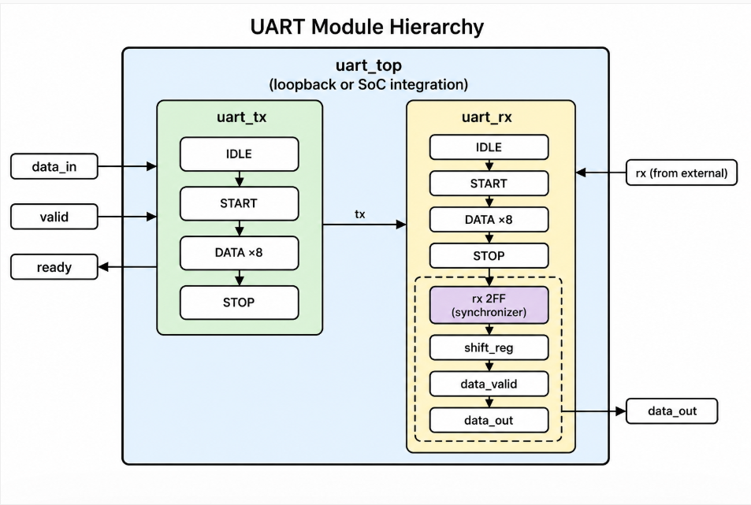

Loopback Test Configuration
In standalone UART testing:
uart_top.uart_tx_out ──→ uart_top.uart_rx_in (internally looped)
The testbench tb/tb_uart_top.v sends a byte through TX, which loops back to RX, and verifies the received byte matches.

Baud Rate Timing Diagram (115200 baud @ 50 MHz)
Byte: 'A' = 0x41 = 0b00100001
Wire: 1 0 1 0 0 0 0 1 0 0 1 1
↑ ↑ ↑ ↑ ↑ ↑ ↑ ↑ ↑ ↑ ↑ ↑
I S D0D1D2D3D4D5D6D7 T I
d t o d
l a p l
e r e
Each bit lasts 434 clock cycles (8.68 µs at 50 MHz).

5. Implementation

Files in This Module
File | Role
rtl/uart_tx.v | UART Transmitter — 8N1, FSM-based, parameterized baud rate
rtl/uart_rx.v | UART Receiver — 8N1, mid-bit sampling, 2-FF synchronizer
rtl/uart_top.v | Top wrapper for standalone UART test (TX + RX connected)
tb/tb_uart_top.v | Testbench driving bytes through UART TX and verifying RX

UART Parameters (from RTL)
parameter CLK_FREQ = 50_000_000; // 50 MHz system clock
parameter BAUD_RATE = 115_200; // 115200 baud
// Derived: CLKS_PER_BIT = 50_000_000 / 115_200 = 434

Key Design Decisions
- ASIC-clean: All registers reset via posedge reset — no = value inline initializers
- 2-FF synchronizer: rx_sync0 → rx_sync1 prevents metastability on async RX input
- Mid-bit sampling: RX waits CLKS_HALF_BIT - 1 before sampling start bit, then samples every CLKS_PER_BIT — robust against ±2.5% timing variation
- Glitch filter: If RX goes high during START state (before half-bit timeout), FSM returns to IDLE (false start rejection)

6. Lab / Hands-on Section

Step 1: Run UART Standalone Simulation
cd /home/deep/nielit/projects/tested_projects/picorv32_soc
make uart
This command: 1. Cleans obj_uart/ 2. Compiles: uart_tx.v + uart_rx.v + uart_top.v + tb_uart_top.v 3. Runs ./obj_uart/sim_uart → produces tb_uart.vcd 4. Opens GTKWave

Expected Terminal Output
--------------------------------------------------
UART Standalone Simulation
--------------------------------------------------
[UART TB] Sending byte: 0x48 ('H')
[UART TB] Received: 0x48 ('H') ← PASS
[UART TB] Sending byte: 0x65 ('e')
[UART TB] Received: 0x65 ('e') ← PASS
...
[UART TB] String "hello deepak" verified: ALL PASS

Step 2: View UART Waveform
gtkwave tb_uart.vcd &
# or use pre-saved layout:
gtkwave tb_uart.vcd -a uart.gtkw &
Add these signals:
clk
reset
uart_top.tx
uart_top.rx
uart_tx.state
uart_tx.clk_cnt[9:0]
uart_tx.shift_reg[7:0]
uart_tx.bit_cnt[2:0]
uart_rx.state
uart_rx.data_out[7:0]
uart_rx.data_valid

Step 3: Measure Bit Period
In GTKWave: 1. Click on the tx signal 2. Place a marker at the falling edge of the start bit 3. Place another marker 434 cycles later 4. Verify the bit transitions align with marker spacing (≈ 8.68 µs)

7. Waveform / Verification Insight

TX Side Observations
Signal | What To See
tx | Starts HIGH (idle), drops to 0 (start), then 8 data bits LSB-first, then 1 (stop)
uart_tx.state | Cycles: IDLE(0) → START(1) → DATA(2) → STOP(3) → IDLE(0)
uart_tx.clk_cnt | Counts 0→433 in each bit, then resets
uart_tx.bit_cnt | Counts 0→7 during DATA state (8 data bits)
uart_tx.shift_reg | Right-shifts each cycle — MSB shifted out, 0 shifted in

RX Side Observations
Signal | What To See
uart_rx.state | IDLE → START → DATA → STOP → IDLE
uart_rx.clk_cnt | Half-bit wait in START; full-bit wait in DATA/STOP
uart_rx.shift_reg | Builds up the received byte bit by bit
uart_rx.data_valid | Single-cycle pulse when byte is complete
uart_rx.data_out | Should match the transmitted byte

Loopback Timing Delay
In waveforms, notice that uart_rx.data_valid pulses approximately:
delay = (1 start + 8 data + 1 stop) × 434 cycles = 10 × 434 = 4340 cycles
≈ 4340 × 20 ns = 86.8 µs after TX starts

8. Common Issues & Debug Tips
Issue | Likely Cause | Fix
data_valid never pulses | RX not connected to TX in loopback | Check uart_top.v for correct TX→RX wire
Received byte is wrong | Bit sampling at edge instead of centre | Verify CLKS_HALF_BIT is correctly CLKS_PER_BIT/2
Framing error (stop=0) | Clock frequency or baud rate mismatch | Verify parameters: CLK_FREQ=50_000_000, BAUD_RATE=115_200
First bit always corrupted | 2-FF synchronizer not reset properly | Check rx_sync0/rx_sync1 reset to 1'b1 (idle)
TX sends garbage | shift_reg loaded wrong | Verify valid pulse triggers shift_reg <= data in IDLE state
GTKWave shows flat TX | valid never raised in testbench | Check testbench sequence starts the send correctly

Debug Snippet: Manually Decode a UART Byte
For BAUD_RATE=115200, CLK_FREQ=50MHz:
CLKS_PER_BIT = 434 cycles
1 frame = 10 bits × 434 cycles = 4340 cycles = 86.8 µs
In GTKWave: 1. Find falling edge of tx (start bit) 2. Jump 217 cycles → confirm tx=0 (centre of start bit) 3. Jump 434 cycles × 8 → sample each data bit at mid-point 4. Build byte from D0(LSB) to D7(MSB)

9. Summary
Concept | Detail
Protocol | Asynchronous serial, no shared clock
Frame format | 8N1: 1 start + 8 data (LSB first) + 1 stop
Baud rate | 115200 baud → 434 cycles/bit at 50 MHz
TX FSM | IDLE → START → DATA(×8) → STOP → IDLE
RX FSM | IDLE → START (half-bit wait) → DATA(×8) → STOP → IDLE
Clock safety | 2-FF synchronizer prevents metastability on async RX input
Glitch filter | RX rejects false start if RX goes high within half-bit time
Lab result | Byte loopback verified: TX data == RX data_out
UART is the output terminal of this SoC. Every uart_puts() call in firmware eventually becomes serial bit transitions on the uart_tx pin — visible in simulation as the [TB] RX byte: log lines.
Previous: Sub-module 2 — AXI-Lite
Next: Sub-module 4 — Memory-Mapped RISC-V + UART

